Customizing ListView
Steps:
- Create a layout with ListView (layout .xml file)
- Create a custom template for the ListView (layout .xml file)
- Based on the template create a data class (. kt file)
- Create a Custom Adapter (. kt file)
- Inside the Activity (. kt file)
  - Create a data source
  - Create the object of Custom Adapter
  - Pass the Custom Adapter to the ListView

1.
<?xml version="1.0" encoding="utf-8"?>
<LinearLayout
xmlns:android="http://schemas.android.com/apk/res/android"
xmlns:tools="http://schemas.android.com/tools"
xmlns:app="http://schemas.android.com/apk/res-auto"
android:layout_width="match_parent"
android:layout_height="match_parent"
tools:context=".CustomListView">
<ListView
android:id="@+id/world"
android:layout_width="match_parent"
android:layout_height="match_parent"/>
</LinearLayout>

2.
Layout >>New >>XML >>Layout XML File
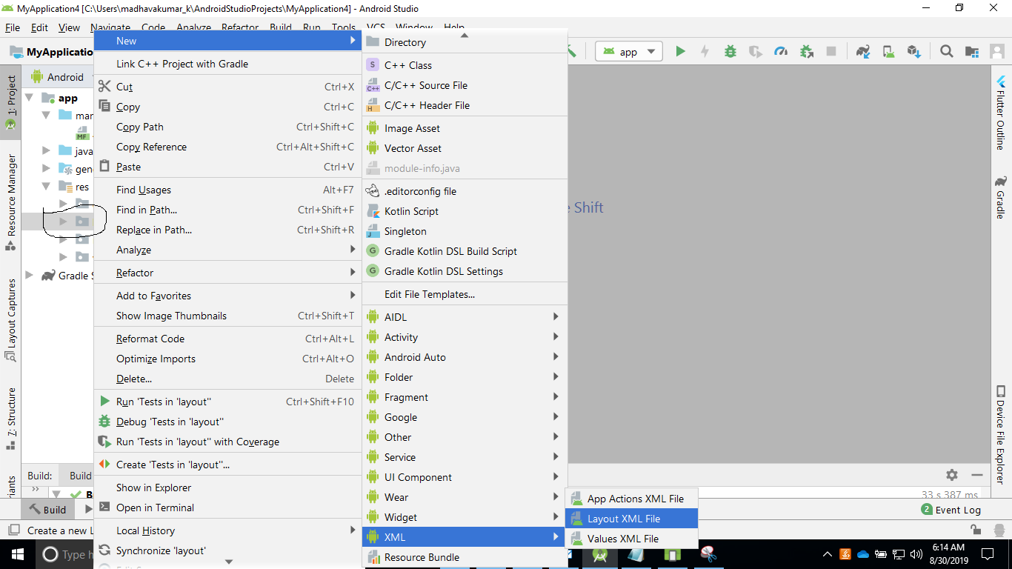
<?xml version="1.0" encoding="utf-8"?>
<LinearLayout xmlns:android="http://schemas.android.com/apk/res/android"
xmlns:app="http://schemas.android.com/apk/res-auto"
android:layout_width="match_parent"
android:layout_height="match_parent">
<ImageView
android:layout_width="100dp"
android:layout_height="60dp"
app:srcCompat="@mipmap/ic_launcher"
android:id="@+id/cflags"
/>
<TextView
android:text=""
android:layout_marginLeft="110dp"
android:layout_width="100dp"
android:layout_height="60dp"
android:id="@+id/cnames"
/>
</LinearLayout>

3.
class Country(var cflags:Int,var cnames:String)

4.
package com.example.myapplication
import android.content.Context
import android.view.LayoutInflater
import android.view.View
import android.view.ViewGroup
import android.widget.ArrayAdapter
import android.widget.BaseAdapter
import android.widget.ImageView
import android.widget.TextView
import kotlinx.android.synthetic.main.my_listview_template.view.*
class CountryAdapter(var ctx:Context,var contries: MutableList<Country>):BaseAdapter() {
override fun getCount(): Int {
return contries.size
}
override fun getItem(position: Int): Any {
return contries[position]
}
override fun getItemId(position: Int): Long {
return position.toLong()
}
override fun getView(position: Int, convertView: View?, parent: ViewGroup?): View {
var cview = LayoutInflater.from(ctx).inflate(R.layout.my_listview_template, null, false)
cview.cflags.setImageResource(contries[position].cflags)
cview.cnames.text = contries[position].cnames
return cview
}
}

or

package com.example.myapplication
import android.content.Context
import android.view.LayoutInflater
import android.view.View
import android.view.ViewGroup
import android.widget.ArrayAdapter
import kotlinx.android.synthetic.main.my_listview_template.view.*
class CountryArrayAdapter(var ctx:Context,var id:Int,var cs: MutableList<Country>): ArrayAdapter<Country>(ctx,id,cs) {
override fun getCount(): Int {
return super.getCount()
}
override fun getView(position: Int, convertView: View?, parent: ViewGroup): View {
var cview= LayoutInflater.from(ctx).inflate(R.layout.my_listview_template,null,false)
cview.cflags.setImageResource(cs[position].cflags)
cview.cnames.text=cs[position].cnames
return cview
}
}

5.

import android.support.v7.app.AppCompatActivity
import android.os.Bundle
import android.widget.Toast
import kotlinx.android.synthetic.main.activity_custom_list_view.*
class CustomListView : AppCompatActivity() {
//var list= mutableListOf<Country>()
var list: MutableList<Country> = mutableListOf()
override fun onCreate(savedInstanceState: Bundle?) {
super.onCreate(savedInstanceState)
setContentView(R.layout.activity_custom_list_view)
list.add(Country(R.drawable.au,"Australia"));
list.add(Country(R.drawable.ca,"Cannada"));
list.add(Country(R.drawable.us,"USA"));
list.add(Country(R.drawable.nz,"NewZeland"));
list.add(Country(R.drawable.es,"Spain"));
list.add(Country(R.drawable.mx,"Mexico"));
list.add(Country(R.drawable.us,"USA"));
list.add(Country(R.drawable.gb,"UK"));
var mycAdapter=CountryAdapter(this,list)
// var mycAdapter=CountryArrayAdapter(this,R.layout.my_listview_template,list)
world.adapter=mycAdapter
world.setOnItemClickListener { parent, view, position, id ->
var contry:Country=world.getItemAtPosition(position) as Country
Toast.makeText(applicationContext,contry.cnames,Toast.LENGTH_LONG).show();
}
}
}

Output:
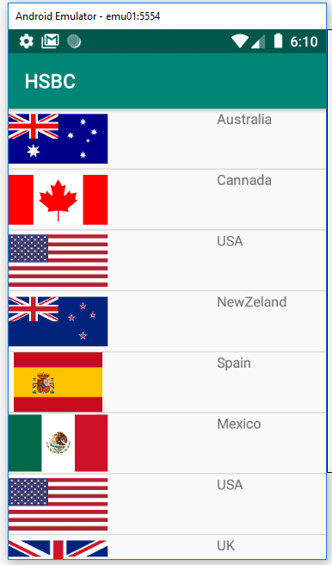

Enhancing the Performance of a ListView using VH design pattern

- Modify the CustomAdapter by creating an inner class inside it, which holds the UI elements for the custom template
- Implement the ViewHolder inside the getView method

import android.content.Context
import android.view.LayoutInflater
import android.view.View
import android.view.ViewGroup
import android.widget.ArrayAdapter
import android.widget.BaseAdapter
import android.widget.ImageView
import android.widget.TextView
import kotlinx.android.synthetic.main.my_listview_template.view.*
class CountryAdapter(var ctx:Context,var contries: MutableList<Country>):BaseAdapter() {
class CountryVH(view: View){
lateinit var tv:TextView
lateinit var img:ImageView
init {
tv=view.cnames
img=view.cflags
}
}
override fun getCount(): Int {
return contries.size
}
override fun getItem(position: Int): Any {
return contries[position]
}
override fun getItemId(position: Int): Long {
return position.toLong()
}
override fun getView(position: Int, convertView: View?, parent: ViewGroup?): View {
/* var cview= LayoutInflater.from(ctx).inflate(R.layout.my_listview_template,null,false)
cview.cflags.setImageResource(contries[position].cflags)
cview.cnames.text=contries[position].cnames
return cview*/
var countryVH:CountryVH
var cview:View
if(convertView==null){
cview= LayoutInflater.from(ctx).inflate(R.layout.my_listview_template,null,false)
countryVH=CountryVH(cview)
cview.tag=countryVH
}else{
cview=convertView
countryVH=cview.tag as CountryVH
}
var conrty:Country=getItem(position) as Country
countryVH.img.setImageResource(conrty.cflags)
countryVH.tv.text=conrty.cnames
return cview
}

